# Day 1 - Deploy dc02

**Basics tab**
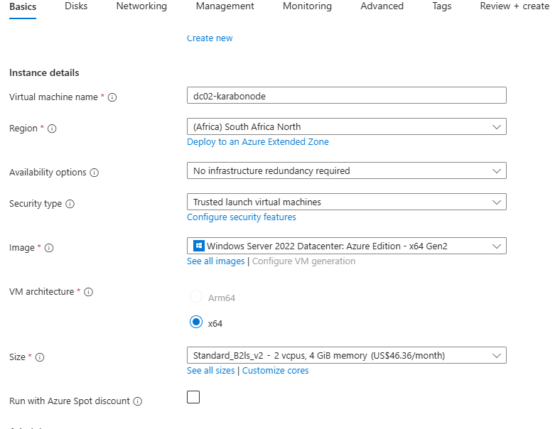
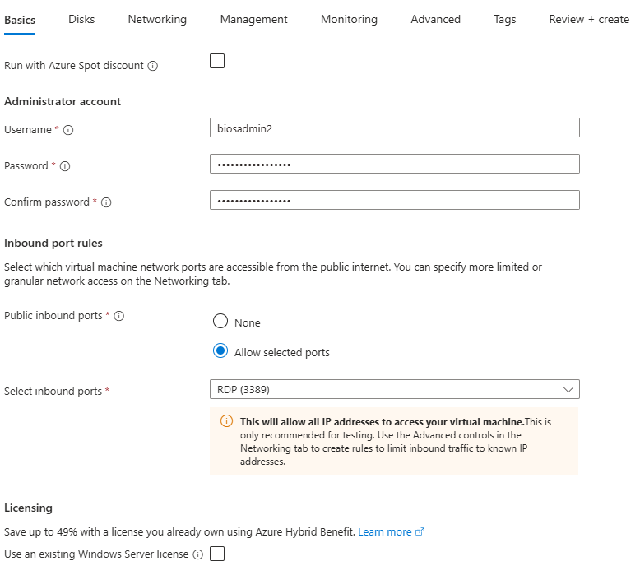
**Disks tab**

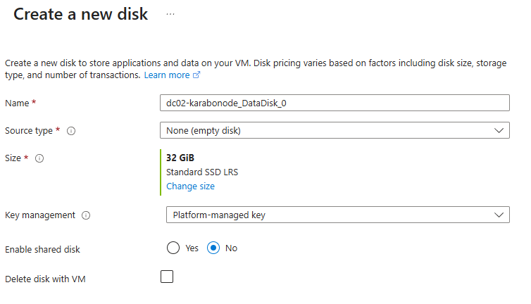

*Networking tab**
- Virtual network: `vnet-karabonode`, subnet: `default` — **the same VNet as `dc01`**, since replication requires network reachability between the two DCs
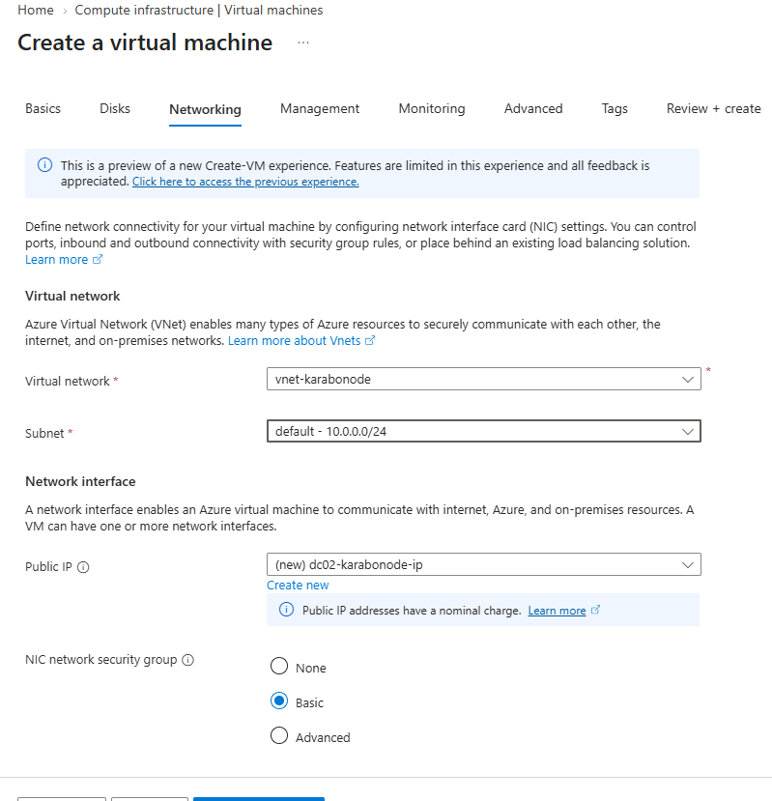
Review + create.
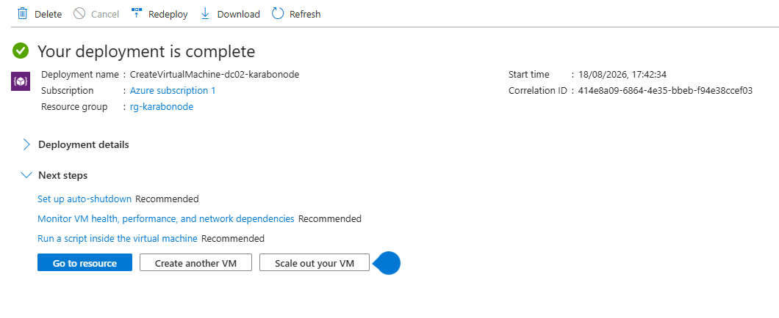
2. **Lock down the NSG** exactly as with `dc01`. VM > **Networking > Network security group > Inbound security rules** > edit the RDP (3389) rule > change **Source** to **My IP address** > save.
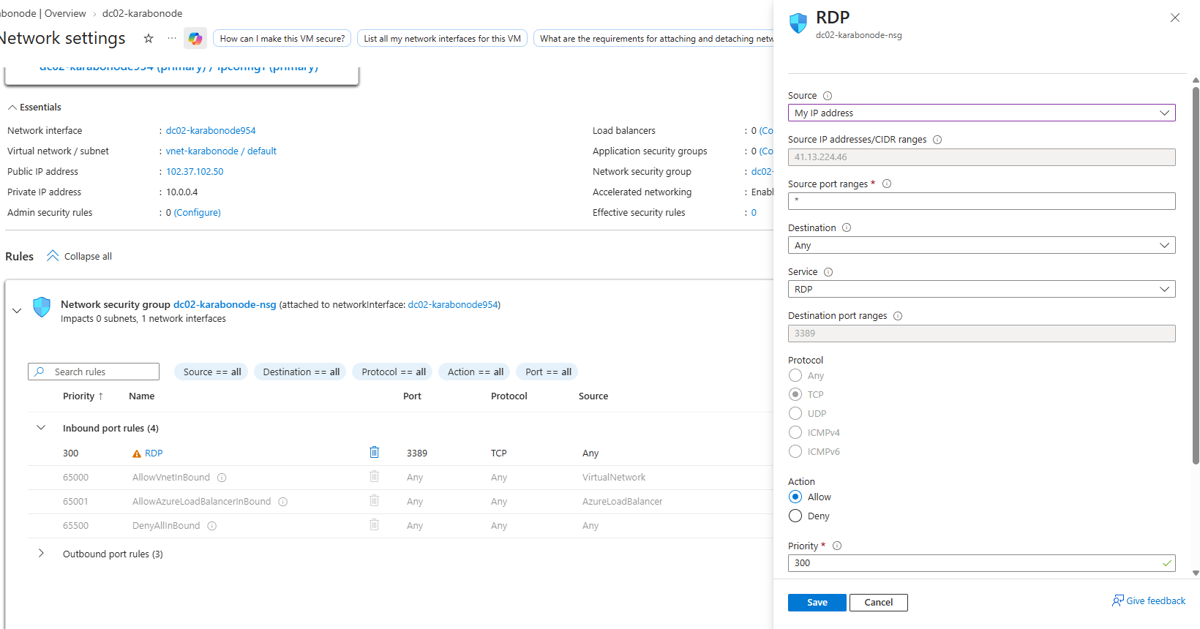

3. **Connect and initialize the data disk as `F:`**

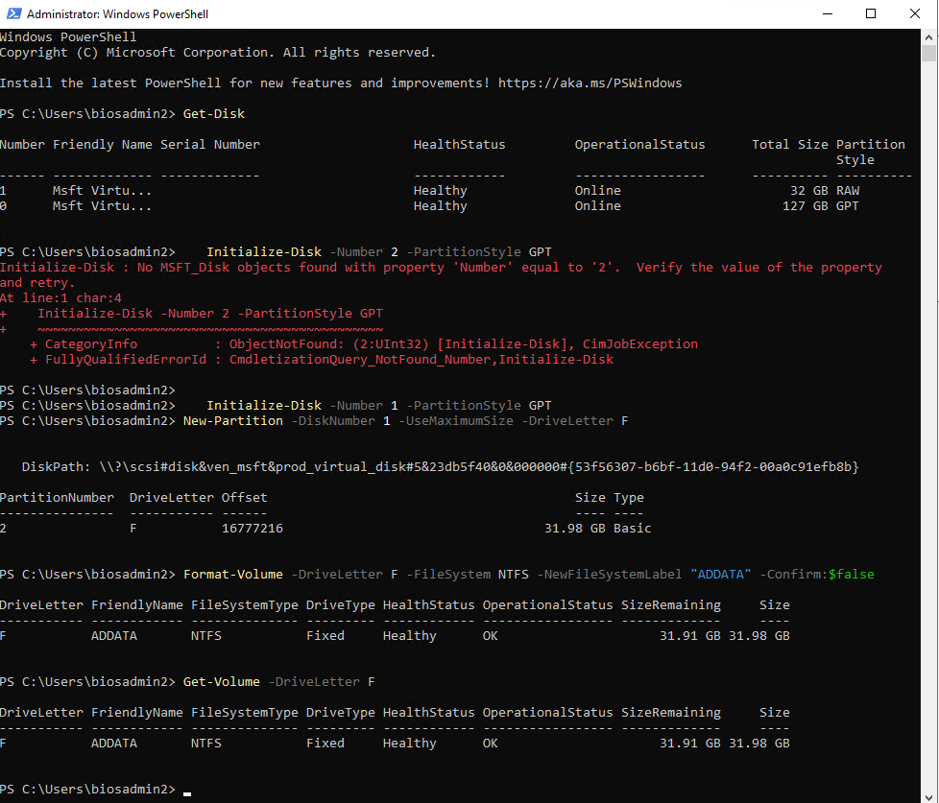

## Why this matters
A second DC is what makes replication - and its failure modes - something you can actually practice.

